**NAME : SURAJ SAHANI**

**TOPIC : CALORIE TRACKING**

**TECHNOLOGY USED TO DEVELOP THIS WEB APPLICATION : -**

**1)FRONTEND DEVELOPMENT :- HTML & CSS**

**2)BACKEND DEVELOPMENT :- DJANGO**

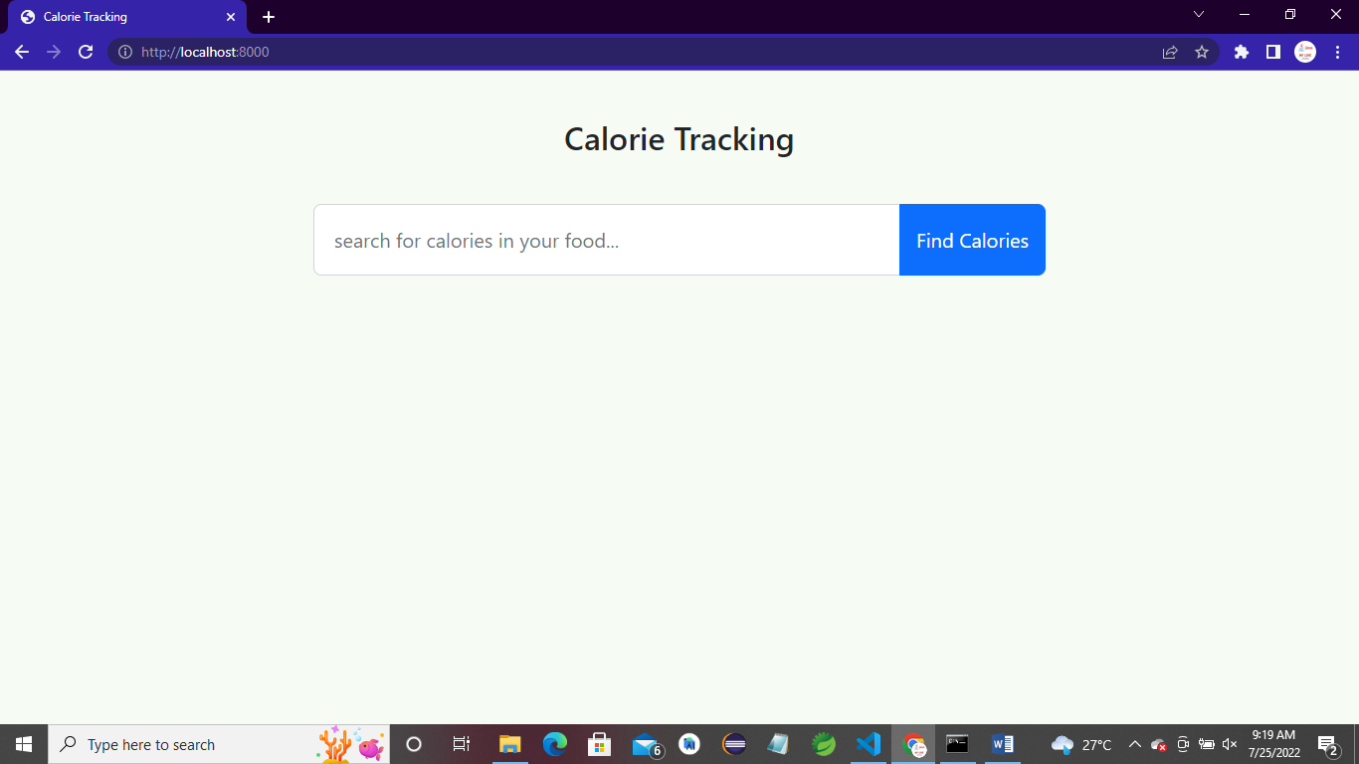

**PIZZA :-**

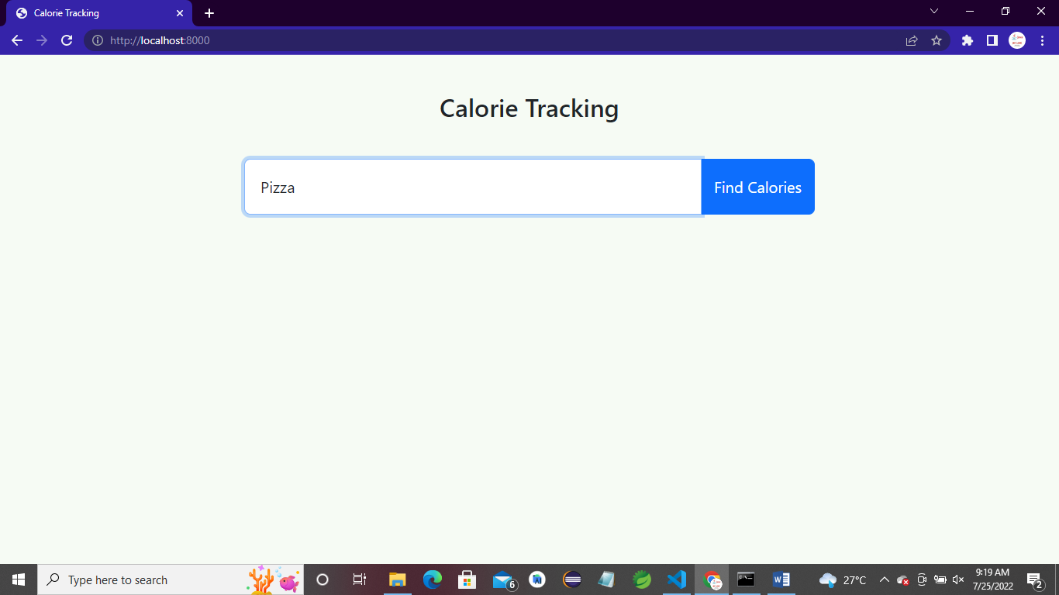

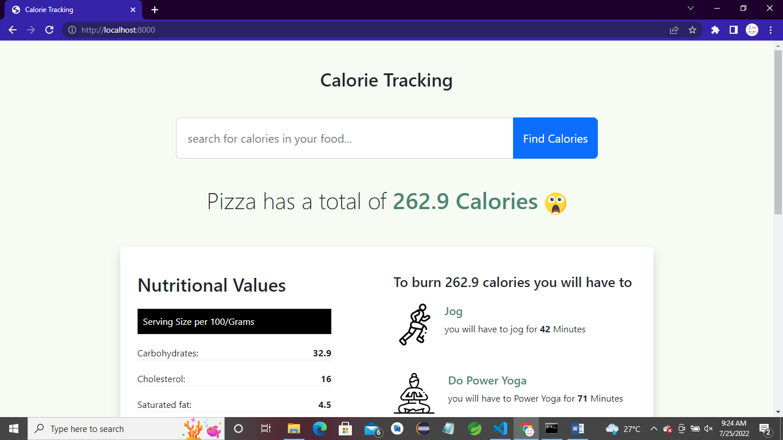

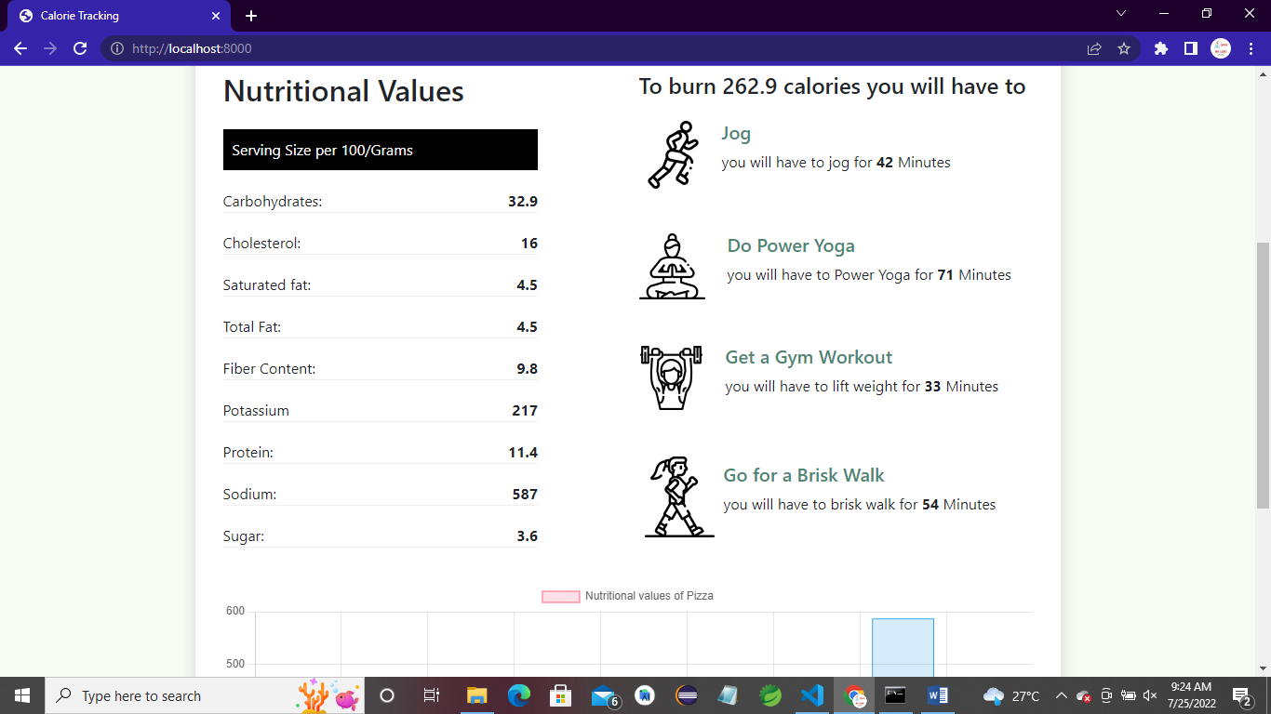

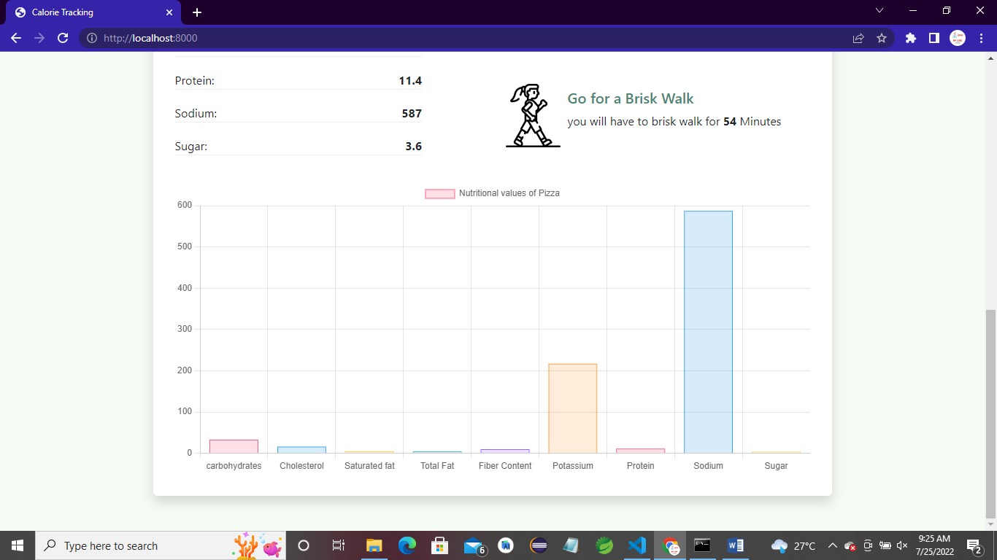

**BURGER :-**

